GO-STANDARD NURSERY & PRI-SCHOOL

END OF YEAR EXAMINATION 2023
BABY CLASS: (3 – 4 YEARS)
LEARNING AREA 5: LANGUAGE DEVELOPMENT II

My name is: …………………………………..………………………….
My School is: ……………………………..………….…………………..
I am in: ………………………………..………………………………………………..
1. Ring sound O
b o x

o r a n g e

s o u n d

p o t

o x e n

b a l l o o n

s a l o o n

3. Match a sound to a sound.
S d
o c
f s
c f
d o
2. Match a sound to a picture.
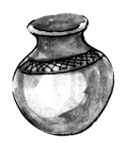
b



a


e


c
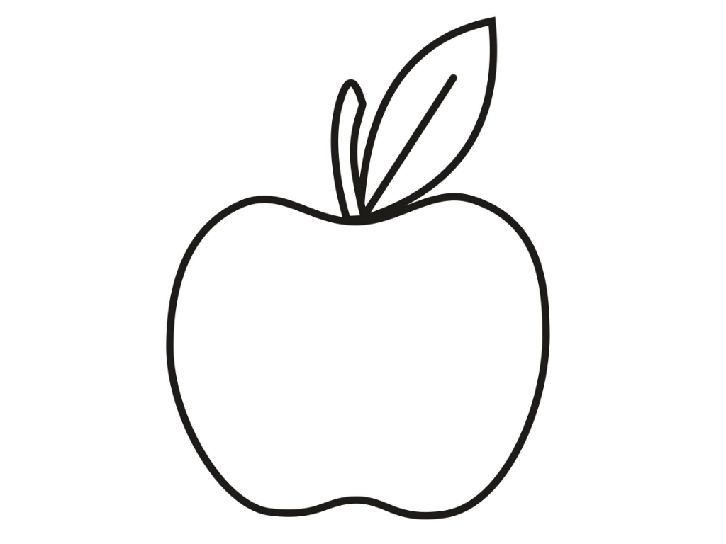
p
4. Read and draw.
box sun cup

5. Match a word to a word and Read.
bell box
box bag
bus bull
bull bell
bag bus
6. Circle the odd man out.
S S C S
box box ball box
o b o o
boy girl boy boy
g b b b
7. Trace the words correctly.

8. Read these words and write
box ________________________________________
axe _________________________________________
cup ________________________________________
cat _________________________________________
bag _________________________________________

“Good Luck”

